PTA MEMBERSHIP FORM

YOUR NAME _______________________________________________________________________________

ADDITIONAL PAYING MEMBERS NAME (S) _______________________________________________________

CHILDS NAME GRADE TEACHER

______________________________ ________________ ____________________________

______________________________ ________________ ____________________________

______________________________ ________________ ____________________________

______________________________ ________________ ____________________________

FULL ADDRESS: ____________________________________________________________________________

PHONE NUMBER: __________________________________________________________________________

EMAIL ADDRESS: ___________________________________________________________________________

The fee to join PTA is $10 per member. Please make checks payable to “Castle Heights Elementary PTA”.
Return to the PTA Box in the front office with completed form attached. Or scan Paypal QR below and email form to chespta90034@gmail.com THANK YOU!
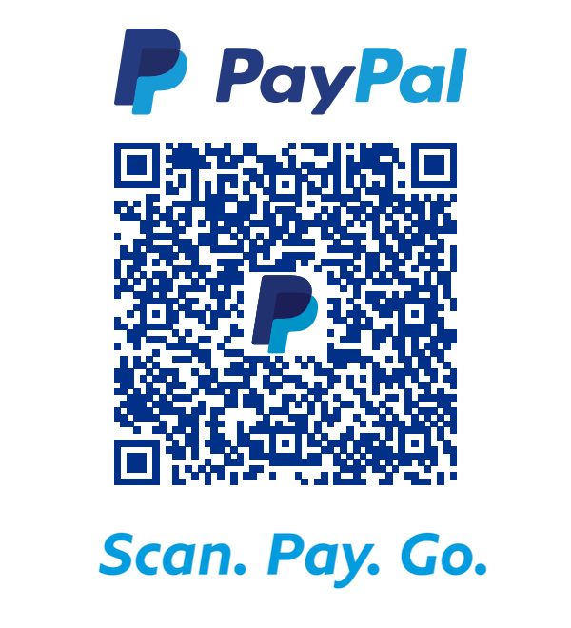
FORMULARIO DE MEMBRESÍA DE LA PTA

SU NOMBRE ____________________________________________________________________________

NOMBRE ADICIONAL DE MEIMBROS QUE PAGAN___________________________________________________________

EL NOMBRE DEL MENOR GRADO MAESTRO/A

______________________________ ________________ ____________________________

______________________________ ________________ ____________________________

______________________________ ________________ ____________________________

______________________________ ________________ ____________________________

DIRECCION COMPLETA: _____________________________________________________________________

NUMERO DE TELEFONO: ____________________________________________________________________

DIRECCION DE CORREO ELECTRINICO: __________________________________________________________
La cuota para unirse a la PTA es $10 por miembro. Haga los cheques a nombre de “Castle Heights Elementary PTA”. Regrese a la PTA Box en la oficina principal con el formulario complete adjunto. O escanee el código QR de Paypal a continuación y envíe el formulario de correo electronico a chespta90034@gmail.com ¡GRACIAS!

